Civil war in Sierra Leone

UNSC Resolution: | 1470
Date of adoption: | 28 March 2003
Operative paragraph: | 14
Demand number: | 2

Megan MacKenzie

Wording of demand
maintain intensive patrolling of the border with Liberia

List of addressees of the demand
Government of Sierra Leone

Short-term compliance

Description of the addressee(s)’ conduct

7. The climate of instability in Sierra Leone’s immediate neighbourhood
continues to add to the internal security risks. The conflict in Liberia, in particular,
could have a far-reaching destabilizing effect on Sierra Leone and on the wider
Mano River subregion. The fighting between the Liberians United for
Reconciliation and Democracy (LURD) and the Armed Forces of Liberia (AFL) has
created conditions of insecurity in the border areas. Combatants deserting both sides
and seeking refuge in Sierra Leone have given rise to fears about a possible
spillover in the fighting.
15. The Republic of Sierra Leone Armed Forces (RSLAF) continued to take steps
to overcome the challenges posed by its restructuring and to provide external
security for the country. The restructuring of the force, which should result in the
reduction of its personnel from the current level of about 14,000 to about 10,500
troops, is ongoing. With the support of the International Military Advisory and
Training Team (IMATT), the army has introduced various initiatives to enhance its
reputation as a disciplined, reliable and professional institution. A third of the
RSLAF troops are currently deployed in the Sierra Leone-Liberia border areas. This
has severely overstretched the force as its operations are still being hampered by
lack of the necessary infrastructure, inadequate logistics, and the poor state of its
aged transport fleet. These challenges will have to be addressed urgently if the army
is to have any chance of meeting its operational obligations along the border areas
without UNAMSIL’s support.

Assessment

Short-term compliance
No or marginal compliance (1) | Medium low compliance (2) | x Medium high compliance (3) | Full or almost full compliance (4)

Considerations underlying the assessment
There is evidence that personnel and resources were dedicated to monitoring the border but that it was achieving limited success.

Medium-term compliance

Description of the addressee(s)’ conduct

4. The relationship between the Republic of Sierra Leone Armed Forces and the
Sierra Leone police continued to improve, as the leadership of the two security
agencies committed themselves to enhancing cooperation, as stressed in their joint
communiqué of 9 August. In addition, joint operations undertaken recently by the
two entities, particularly in the border areas, have helped to foster better tactical
coordination between the security forces.
6. There have been no major external threats to the security of Sierra Leone
during the period under review. The situation in Liberia has continued to stabilize,
despite the recent disturbances in Monrovia. In addition, the security situation on
the border with Liberia has improved with the deployment of the United Nations
Mission in Liberia (UNMIL) and also the deployment of immigration officials from
the National Transitional Government of Liberia at major border crossings. Joint
border patrols by the Sierra Leone police and armed forces have increased with the
support of UNAMSIL.

Assessment

Medium-term compliance
No or marginal compliance (1) | Medium low compliance (2) | Medium high compliance (3) | x Full or almost full compliance (4)

Considerations underlying the assessment

It is clear from this report that resources had been dedicated to border control and monitoring.

Depth of demand

Assessment

Level of depth of demand
x Low depth of demand (1) | Medium depth of demand (2) | High depth of demand (3)

Considerations underlying the assessment

Level of confidence about coding decisions

Level of confidence about coding decision
Extremely high | x High | Moderate

Comments to IPI (if any)

Civil war in Sierra Leone

UNSC Resolution: | 1470
Date of adoption: | 28 March 2003
Operative paragraph: | 15
Demand number: | 1

Megan MacKenzie

Wording of demand
pay special attention to the needs of women and children affected by the war, bearing in mind paragraph 42 of the report of the Secretary-General of 17 March 2003 (S/2003/321)

List of addressees of the demand
Government of Sierra Leone

Short-term compliance

Description of the addressee(s)’ conduct

52. During the reporting period, UNAMSIL’s Human Rights Section continued to
promote women’s rights with its monitoring and capacity-building activities.
UNAMSIL visits to police stations, prisons and courts have been conducted with a
special focus on cases involving women and girls. In April 2003, UNAMSIL acted
as a facilitator in an exercise to field-test gender mainstreaming, developed by a
team from the Peacekeeping Best Practices Unit of the Department of Peacekeeping
Operations. Gender training has been delivered to peacekeepers and CIVPOL
officers. UNAMSIL has also completed the first phase of training of members of the
Family Support Units of the Sierra Leone police, which have the mandate to deal
with offences against women, children and vulnerable groups.
41. Significant progress has been made in the efforts to promote human rights,
national reconciliation and justice, and in addressing the needs of children affected
by the conflict, which are key aspects of the overall peace consolidation strategy. In
this connection, the work of the Court and the Truth and Reconciliation Commission
has gathered pace.

Assessment

Short-term compliance
No or marginal compliance (1) | Medium low compliance (2) | x Medium high compliance (3) | Full or almost full compliance (4)

Considerations underlying the assessment
Special effort and attention was dedicated to children and women in coordination with UNICEF and the United Nations Mission in Sierra Leone.

Medium-term compliance

Description of the addressee(s)’ conduct

27. In collaboration with the United Nations country team and other partners,
UNAMSIL has continued to promote women’s rights in Sierra Leone through
training and awareness-raising programmes. In the meantime, principles of the
Convention on the Elimination of All Forms of Discrimination against Women,
which Sierra Leone ratified in 1988, are being incorporated into the country’s draft
laws.
24. UNAMSIL, the United Nations Children’s Fund (UNICEF), and child
protection non-governmental organizations in Sierra Leone have continued to work
with their counterparts in Liberia to ensure that the disarmament, demobilization,
rehabilitation and reintegration programme adequately addresses the issue of Sierra
Leonean children associated with the Liberian fighting forces. ICRC has reunited an
initial group of 12 such Sierra Leonean children with their families. It has identified
a further group of 150 children in Liberia and is taking steps to facilitate the
reunification of the families. Thirty-six Liberian children associated with the
fighting forces in Sierra Leone still remain in refugee camps in the country, while
some 168 have already been repatriated. Family reunification, repatriation and
reintegration activities are being arranged by UNHCR and ICRC, in coordination
with UNICEF in Liberia.

Assessment

Medium-term compliance
No or marginal compliance (1) | Medium low compliance (2) | x Medium high compliance (3) | Full or almost full compliance (4)

Considerations underlying the assessment

Efforts were made in regard to this demand- particularly with the reintegration program and rights; however, there remains serious concern about sexual violence in the country.

Depth of demand

Assessment

Level of depth of demand
x Low depth of demand (1) | Medium depth of demand (2) | High depth of demand (3)

Considerations underlying the assessment

Level of confidence about coding decisions

Level of confidence about coding decision
Extremely high | x High | Moderate

Comments to IPI (if any)

Civil war in Sierra Leone

UNSC Resolution: | 1470
Date of adoption: | 28 March 2003
Operative paragraph: | 16
Demand number: | 3

Megan MacKenzie

Wording of demand
continue to cooperate to this end to fulfil their commitments under the Abuja Ceasefire Agreement of 10 November 2000 (S/2000/1091)

List of addressees of the demand
Government of Sierra Leone, Revolutionary United Front

Short-term compliance

Description of the addressee(s)’ conduct

41. Significant progress has been made in the efforts to promote human rights,
national reconciliation and justice, and in addressing the needs of children affected
by the conflict, which are key aspects of the overall peace consolidation strategy. In
this connection, the work of the Court and the Truth and Reconciliation Commission
has gathered pace.
65. The gradual and carefully calibrated approach to the drawdown of UNAMSIL,
as approved by the Security Council, is yielding the desired benefits. In particular,
the extended presence of the Mission in the country has assured a stable security
environment and enabled the Government to make steady progress in consolidating
peace, and in promoting national reconciliation, justice and national reconstruction.
Tangible progress has been made in the efforts to consolidate peace, including the
reintegration of some 48,000 out of the 57,000 disarmed ex-combatants, the
completion of the resettlement of internally displaced persons, the acceleration of
the repatriation and resettlement of Sierra Leonean refugees, until the disruption by
the recent events in Liberia, and the restoration of the Government’s authority
throughout the country, although much more remains to be done to enhance the
Government’s capacity to deliver public services to the population in the provinces.
The human rights situation in the country continues to improve, while the work of
the Truth and Reconciliation Commission and the Special Court has progressed
satisfactorily, despite the financial difficulties that continue to plague both
organizations.

Assessment

Short-term compliance
No or marginal compliance (1) | Medium low compliance (2) | Medium high compliance (3) | x Full or almost full compliance (4)

Considerations underlying the assessment
The conflict ended and major violence did not continue through this period.

Medium-term compliance

Description of the addressee(s)’ conduct
The situation has remained generally calm and stable in Sierra Leone over the
reporting period. The favourable security environment has facilitated further
progress in the consolidation of peace in the country and has also enabled
UNAMSIL to proceed with the continued drawdown of its military component.
Furthermore, it has been possible for the Mission to transfer the overall primacy for
security responsibility in the country to the Government of Sierra Leone.

Assessment

Medium-term compliance
No or marginal compliance (1) | Medium low compliance (2) | Medium high compliance (3) | x Full or almost full compliance (4)

Considerations underlying the assessment
The conflict had ended and no major fighting or violence occurred during this period.

Depth of demand

Assessment

Level of depth of demand
x Low depth of demand (1) | Medium depth of demand (2) | High depth of demand (3)

Considerations underlying the assessment

Level of confidence about coding decisions

Level of confidence about coding decision
Extremely high | High | Moderate

Comments to IPI (if any)

Civil war in Sierra Leone

UNSC Resolution: | 1508
Date of adoption: | 19 September 2003
Operative paragraph: | 4
Demand number: | 2

Megan MacKenzie

Wording of demand
accelerate the consolidation of civil authority and public services throughout the country, and continue to strengthen the operational effectiveness and capabilities of the security sector

List of addressees of the demand
Government of Sierra Leone

Short-term compliance

Description of the addressee(s)’ conduct
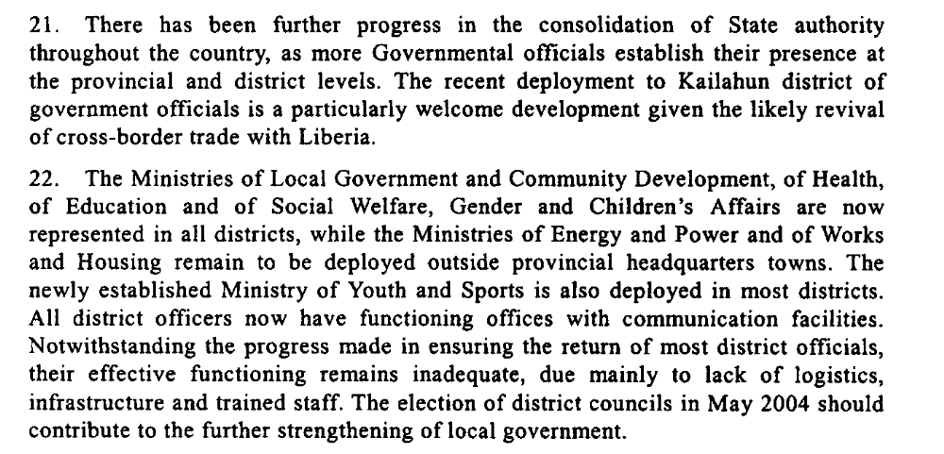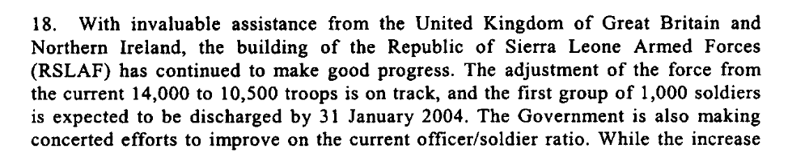

Assessment

Short-term compliance
No or marginal compliance (1) | Medium low compliance (2) | x Medium high compliance (3) | Full or almost full compliance (4)

Considerations underlying the assessment
Clear steps had been taken to consolidate state authority across the country; however, these efforts had some limitations, particularly in terms of logistics.

Medium-term compliance

Description of the addressee(s)’ conduct

46. The Government of Sierra Leone has made commendable efforts to enhance
the control of diamond mining, which has resulted in a considerable increase in
revenues from official diamond exports. This achievement constitutes one of the key
outcomes of the consolidation of State authority across the country. The authorities
should be encouraged to continue further strengthening their control over this sector,
which is essential for the revitalization of the national economy.
17. In collaboration with the World Bank and UNDP, the Government of Sierra
Leone has carried out a training and capacity-building programme to enhance the
effectiveness of the newly elected local authorities. A review of local tax rates by
the local councils, in collaboration with chiefdom authorities, is under way. In the
current economic situation, however, the prospects for significant public revenues to
be generated for funding basic services remain poor.
44. Nonetheless, the lack of infrastructure and adequate equipment continues to
hamper the operational effectiveness of the national security sector, most
particularly in the border areas. Recent donor support, in particular the pledge of the
Government of Switzerland to donate 260 assorted trucks to the Sierra Leone Armed
Forces, as well as the continuing major support by the United Kingdom, has been
most helpful. However, much more remains to be done towards strengthening the
operational capacity of the police and armed forces. In view of this, the Government
and its international partners should intensify efforts aimed at addressing the
infrastructure and logistical needs of the Sierra Leone security sector.

Assessment

Medium-term compliance
No or marginal compliance (1) | Medium low compliance (2) | x Medium high compliance (3) | Full or almost full compliance (4)

Considerations underlying the assessment
The Government had been commended on its progress in extending its authority throughout the country. A lack of resources remained a drawback to this progress.

Depth of demand

Assessment

Level of depth of demand
x Low depth of demand (1) | Medium depth of demand (2) | High depth of demand (3)

Considerations underlying the assessment

Level of confidence about coding decisions

Level of confidence about coding decision
Extremely high | x High | Moderate

Comments to IPI (if any)

Civil war in Sierra Leone

UNSC Resolution: | 1508
Date of adoption: | 19 September 2003
Operative paragraph: | 5
Demand number: | 1

Megan MacKenzie

Wording of demand
continue to strengthen its control over, and regulation of, diamond mining, including through the High Level Steering Committee

List of addressees of the demand
Government of Sierra Leone

Short-term compliance

Description of the addressee(s)’ conduct
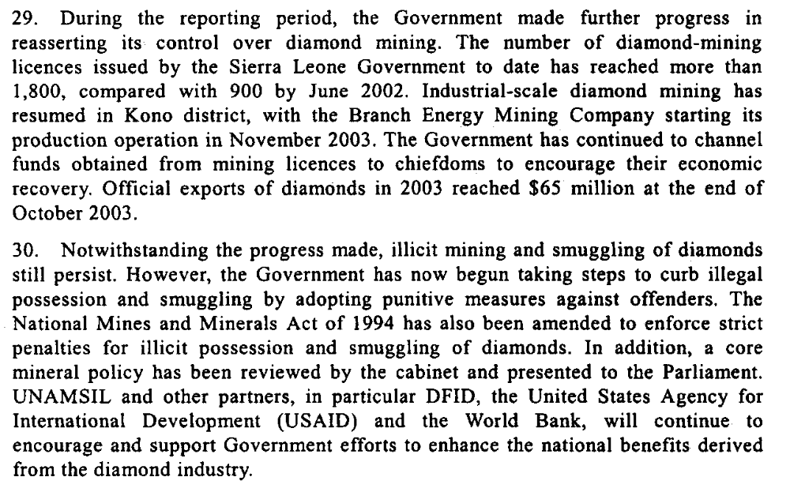

Assessment

Short-term compliance
No or marginal compliance (1) | Medium low compliance (2) | x Medium high compliance (3) | Full or almost full compliance (4)

Considerations underlying the assessment
The Government was made clear efforts to monitor and control the diamond industry during this time. Although illegal sales continued, the Government continued to try to develop means to regulate this industry.

Medium-term compliance

Description of the addressee(s)’ conduct

46. The Government of Sierra Leone has made commendable efforts to enhance
the control of diamond mining, which has resulted in a considerable increase in
revenues from official diamond exports. This achievement constitutes one of the key
outcomes of the consolidation of State authority across the country. The authorities
should be encouraged to continue further strengthening their control over this sector,
which is essential for the revitalization of the national economy.
20. The Government has continued to make progress in expanding its control over
diamond mining. By the end of October, revenues from official diamond exports had
reached $120 million, compared to $71 million during the same period in 2003. This
is largely attributed to the Government’s consistent implementation of the
Kimberley Process Certification Scheme. A Kimberley Process peer review visit to
Sierra Leone and Guinea is scheduled for early in 2005, to address regional
initiatives to prevent the illicit trading and smuggling of diamonds.

Assessment

Medium-term compliance
No or marginal compliance (1) | Medium low compliance (2) | Medium high compliance (3) | x Full or almost full compliance (4)

Considerations underlying the assessment
Despite the challenges to complying with this demand, the Government made considerable efforts. In particular, the Kimberly process was largely seen as a success.

Depth of demand

Assessment

Level of depth of demand
Low depth of demand (1) | x Medium depth of demand (2) | High depth of demand (3)

Considerations underlying the assessment

Level of confidence about coding decisions

Level of confidence about coding decision
Extremely high | x High | Moderate

Comments to IPI (if any)

Civil war in Sierra Leone

UNSC Resolution: | 1508
Date of adoption: | 19 September 2003
Operative paragraph: | 8
Demand number: | 4

Megan MacKenzie

Wording of demand
resume dialogue and implement their commitments to building regional peace and security

List of addressees of the demand
Government of Sierra Leone

Short-term compliance

Description of the addressee(s)’ conduct
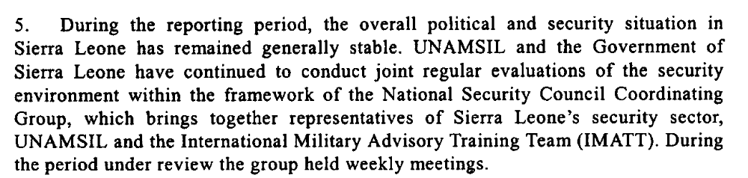

Assessment

Short-term compliance
No or marginal compliance (1) | Medium low compliance (2) | Medium high compliance (3) | x Full or almost full compliance (4)

Considerations underlying the assessment

This was a period characterized by peace and stability and continued efforts by the Government to maintain this stability.

Medium-term compliance

Description of the addressee(s)’ conduct

The situation has remained generally calm and stable in Sierra Leone over the
reporting period. The favourable security environment has facilitated further
progress in the consolidation of peace in the country and has also enabled
UNAMSIL to proceed with the continued drawdown of its military component.
Furthermore, it has been possible for the Mission to transfer the overall primacy for
security responsibility in the country to the Government of Sierra Leone.

Assessment

Medium-term compliance
No or marginal compliance (1) | Medium low compliance (2) | Medium high compliance (3) | x Full or almost full compliance (4)

Considerations underlying the assessment

There were no major incidents of violence during this period, and the Government of Sierra Leone maintained their commitment to peace and stability.

Depth of demand

Assessment

Level of depth of demand
x Low depth of demand (1) | Medium depth of demand (2) | High depth of demand (3)

Considerations underlying the assessment

Level of confidence about coding decisions

Level of confidence about coding decision
Extremely high | x High | Moderate

Comments to IPI (if any)

Civil war in Sierra Leone

UNSC Resolution: | 1508
Date of adoption: | 19 September 2003
Operative paragraph: | 9
Demand number: | 3

Megan MacKenzie

Wording of demand
maintain intensive patrolling of the border with Liberia

List of addressees of the demand
Government of Sierra Leone

Short-term compliance

Description of the addressee(s)’ conduct

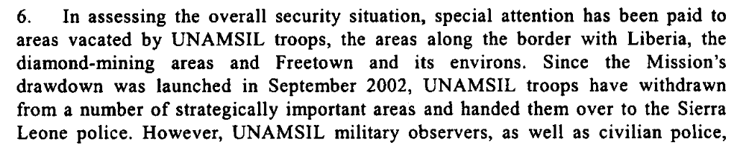

Assessment

Short-term compliance
No or marginal compliance (1) | Medium low compliance (2) | x Medium high compliance (3) | Full or almost full compliance (4)

Considerations underlying the assessment
As UNAMSIL drew down, the Government of Sierra Leone dedicated resources and attention to monitoring the border with Liberia.

Medium-term compliance

Description of the addressee(s)’ conduct

4. The relationship between the Republic of Sierra Leone Armed Forces and the
Sierra Leone police continued to improve, as the leadership of the two security
agencies committed themselves to enhancing cooperation, as stressed in their joint
communiqué of 9 August. In addition, joint operations undertaken recently by the
two entities, particularly in the border areas, have helped to foster better tactical
coordination between the security forces.
6. There have been no major external threats to the security of Sierra Leone
during the period under review. The situation in Liberia has continued to stabilize,
despite the recent disturbances in Monrovia. In addition, the security situation on
the border with Liberia has improved with the deployment of the United Nations
Mission in Liberia (UNMIL) and also the deployment of immigration officials from
the National Transitional Government of Liberia at major border crossings. Joint
border patrols by the Sierra Leone police and armed forces have increased with the
support of UNAMSIL.

Assessment

Medium-term compliance
No or marginal compliance (1) | Medium low compliance (2) | x Medium high compliance (3) | Full or almost full compliance (4)

Considerations underlying the assessment
With the help of UNAMSIL, the Government of Sierra Leone maintained intensive monitoring of the border with Liberia.

Depth of demand

Assessment

Level of depth of demand
x Low depth of demand (1) | Medium depth of demand (2) | High depth of demand (3)

Considerations underlying the assessment

Level of confidence about coding decisions

Level of confidence about coding decision
Extremely high | x High | Moderate

Comments to IPI (if any)

United Nations Secretary-General. Eighteenth Report of the Secretary General on the United Nations Mission in Sierra Leone 23 June 2003.
United Nations Secretary-General. Twenty-fourth Report of the Secretary General on the United Nations Mission in Sierra Leone. 10 December 2004.
United Nations Secretary-General. Eighteenth Report of the Secretary General on the United Nations Mission in Sierra Leone 23 June 2003.
United Nations Secretary-General. Twenty-fourth Report of the Secretary General on the United Nations Mission in Sierra Leone. 10 December 2004.
United Nations Secretary-General. Eighteenth Report of the Secretary General on the United Nations Mission in Sierra Leone 23 June 2003.
United Nations Secretary-General. Twenty-fourth Report of the Secretary General on the United Nations Mission in Sierra Leone. 10 December 2004.
United Nations Secretary-General. Twentieth Report of the Secretary General on the United Nations Mission in Sierra Leone. 23 December 2003.
United Nations Secretary-General. Twenty-fourth Report of the Secretary General on the United Nations Mission in Sierra Leone. 10 December 2004.
United Nations Secretary-General. Twentieth Report of the Secretary General on the United Nations Mission in Sierra Leone. 23 December 2003.
United Nations Secretary-General. Twenty-fourth Report of the Secretary General on the United Nations Mission in Sierra Leone. 10 December 2004.
United Nations Secretary-General. Twentieth Report of the Secretary General on the United Nations Mission in Sierra Leone. 23 December 2003.
United Nations Secretary-General. Twenty-fourth Report of the Secretary General on the United Nations Mission in Sierra Leone. 10 December 2004.
United Nations Secretary-General. Twentieth Report of the Secretary General on the United Nations Mission in Sierra Leone. 23 December 2003.
United Nations Secretary-General. Twenty-fourth Report of the Secretary General on the United Nations Mission in Sierra Leone. 10 December 2004.

